1. 在“用户系统”的数据库创建表：员工表（emp）包括的字段：empno员工号/ename员工姓名/job工作/mgr上级编号/hiredate受雇日期/sal薪金/comm佣金/deptno部门编号)
2. 插入的数据如下：

|  |
| --- |
| insert into emp values('7499' , 'ALLEN' , ‘SALESMAN’,’7698’,'2022-2-20' ,1600,300, '30');  insert into emp values('7521' , 'WARD' , ‘SALESMAN’,’7698’,'2022-2-22' ,1250,500, '30');  insert into emp values('7654' , 'MARTIN' , ‘SALESMAN’,’7698’,'2022-9-28' ,1250,1400, '20');  insert into emp values('7844' , 'TURNER' , ‘SALESMAN’,’7698’,'2022-9-8' ,1500,0, '30');  insert into emp(empno,ename,job,mgr,hiredate,sal,deptno) values('7698' , 'BLAKE' , ‘MANAGER’,’7839’,'2022-5-1' ,2850 '30');  insert into emp(empno,ename,job,mgr,hiredate,sal,deptno) values('7900' , 'JAMES' , ‘CLERK’,’7698’,'2022-12-3' ,900,'10');  insert into emp(empno,ename,job,mgr,hiredate,sal,deptno) values('7100' , 'JAMES' , ‘CLERK’,’7698’,'2022-12-3' ,900,'20'); |

完成下面查询：

1、显示雇员的详细资料，按姓名排序

|  |
| --- |
| select *  from emp  order by ename |

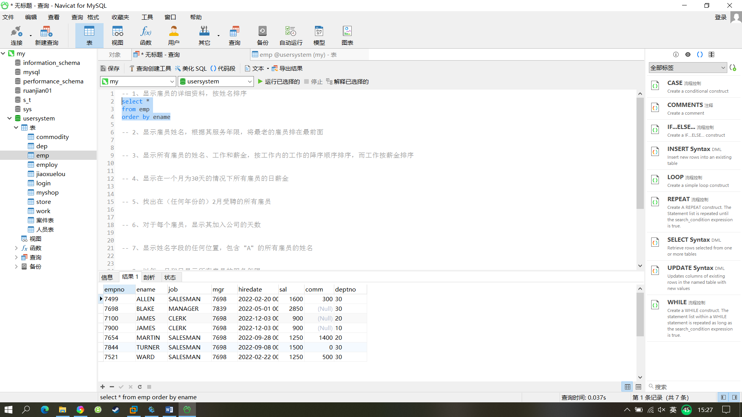

2、显示雇员姓名，根据其服务年限，将最老的雇员排在最前面

|  |
| --- |
| select ename,hiredate  from emp  order by hiredate asc |

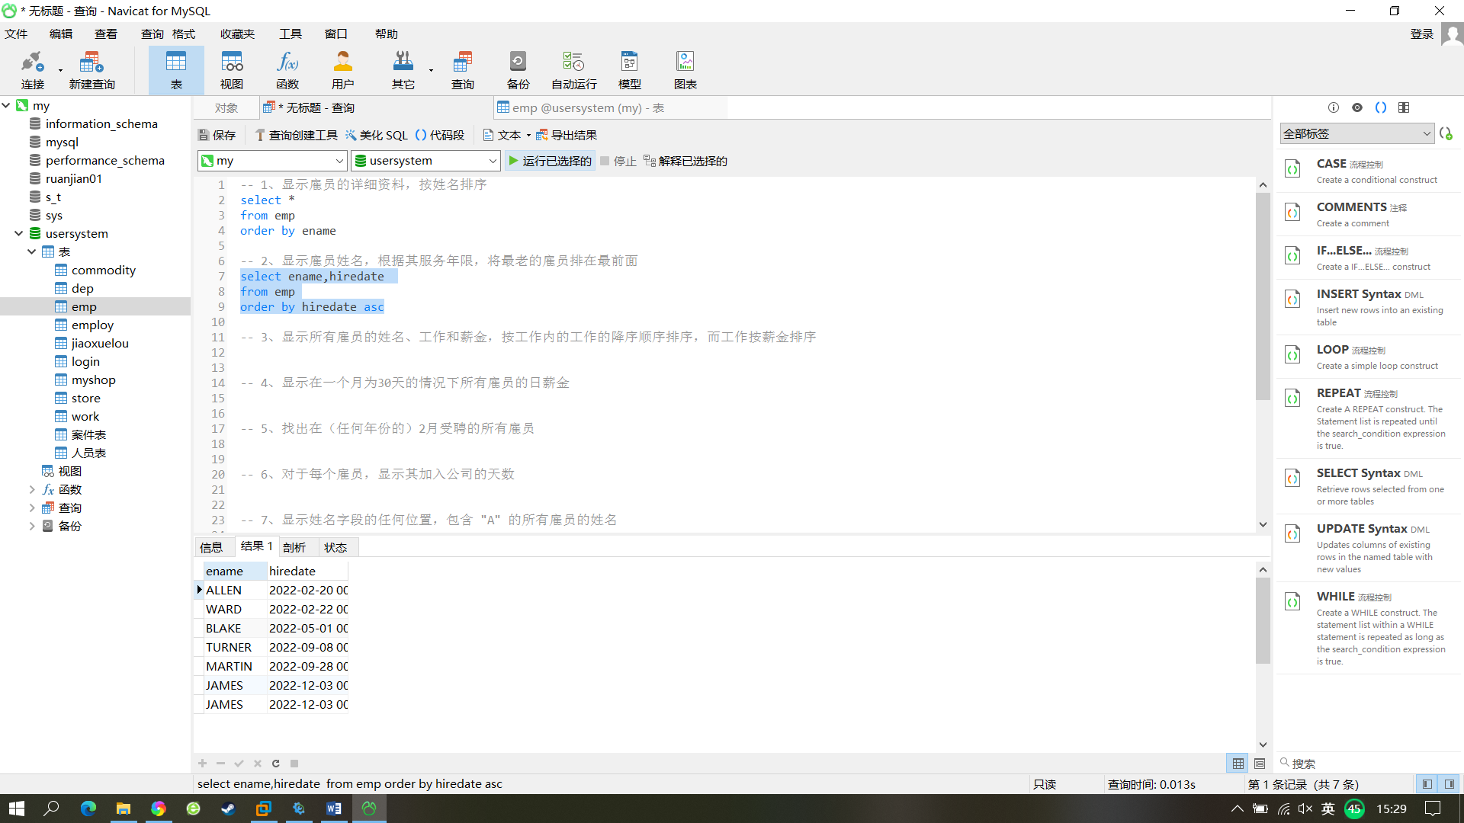

3、显示所有雇员的姓名、工作和薪金，按工作内的工作的降序顺序排序，而工作按薪金排序

|  |
| --- |
| select ename,job,sal  from emp  order by job DESC,sal |

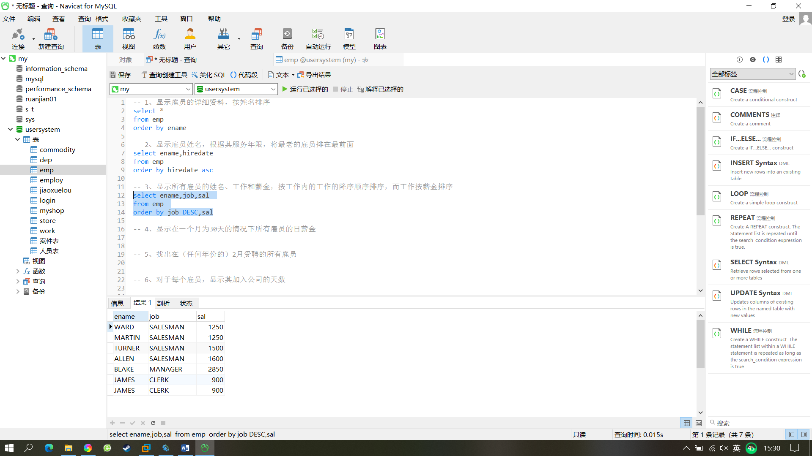

4、显示在一个月为30天的情况下所有雇员的日薪金

|  |
| --- |
| select ename, sal , sal/30 as '日薪'  from emp |

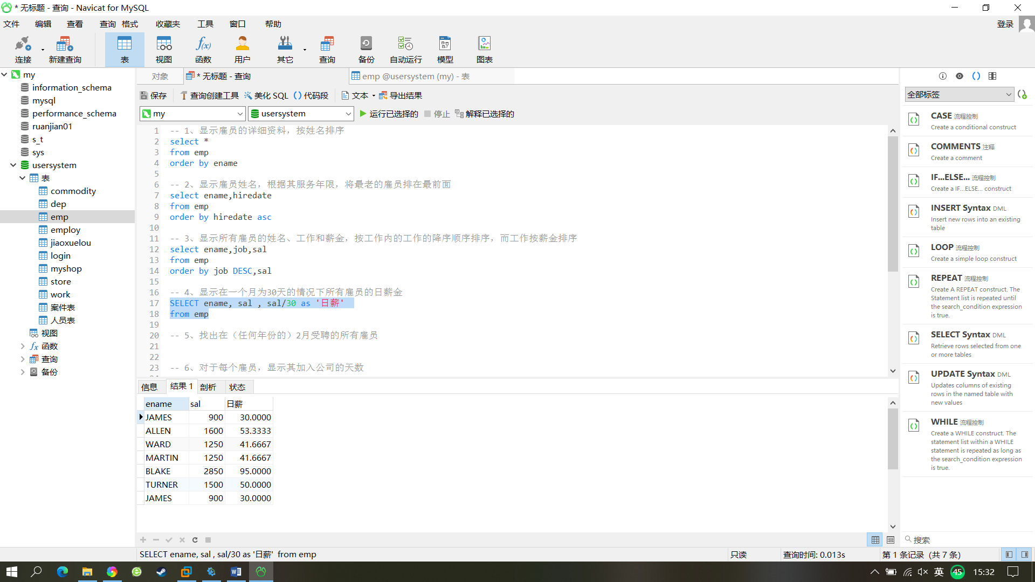

5、找出在（任何年份的）2月受聘的所有雇员

|  |
| --- |
| select ename ,hiredate  from emp  where DATE_FORMAT(hiredate,'%m')='02' |

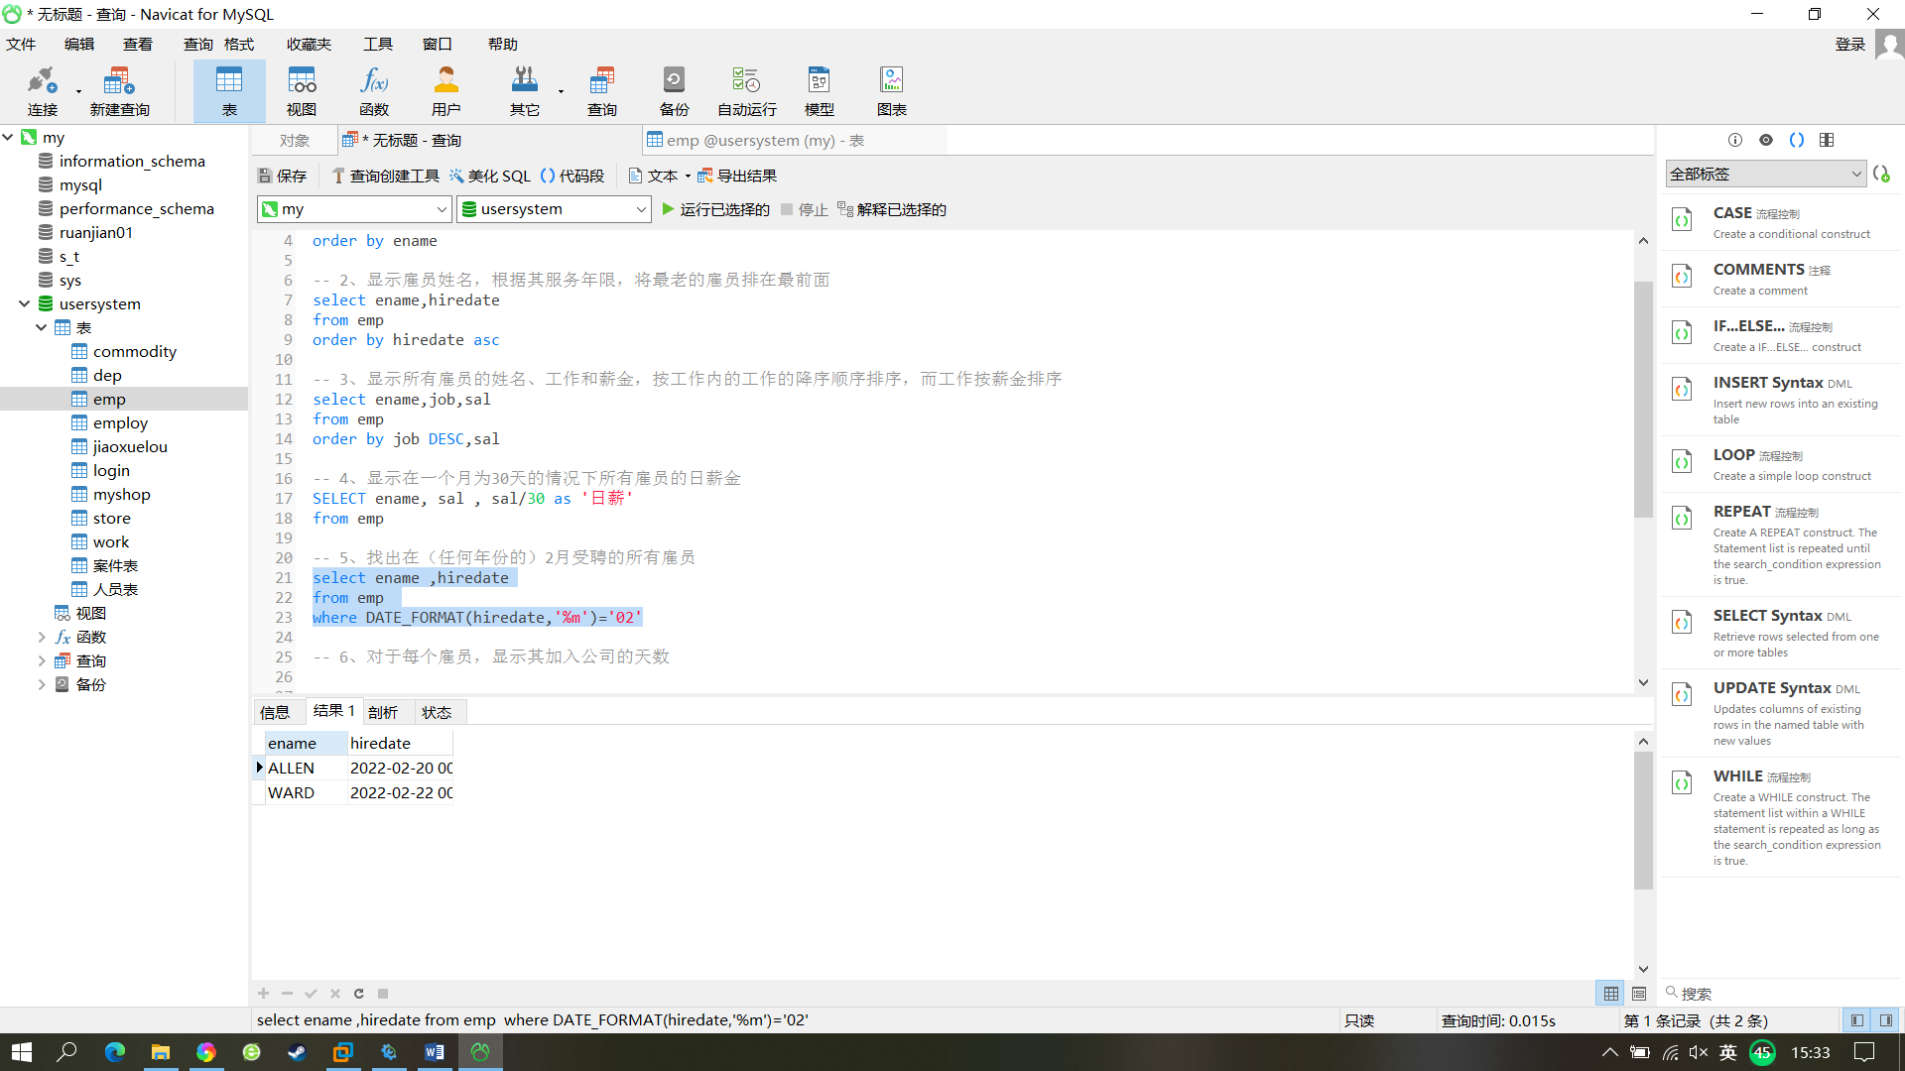

6、对于每个雇员，显示其加入公司的天数

|  |
| --- |
| SELECT ename,DATEDIFF(now(),hiredate) as '加入天数' from emp |

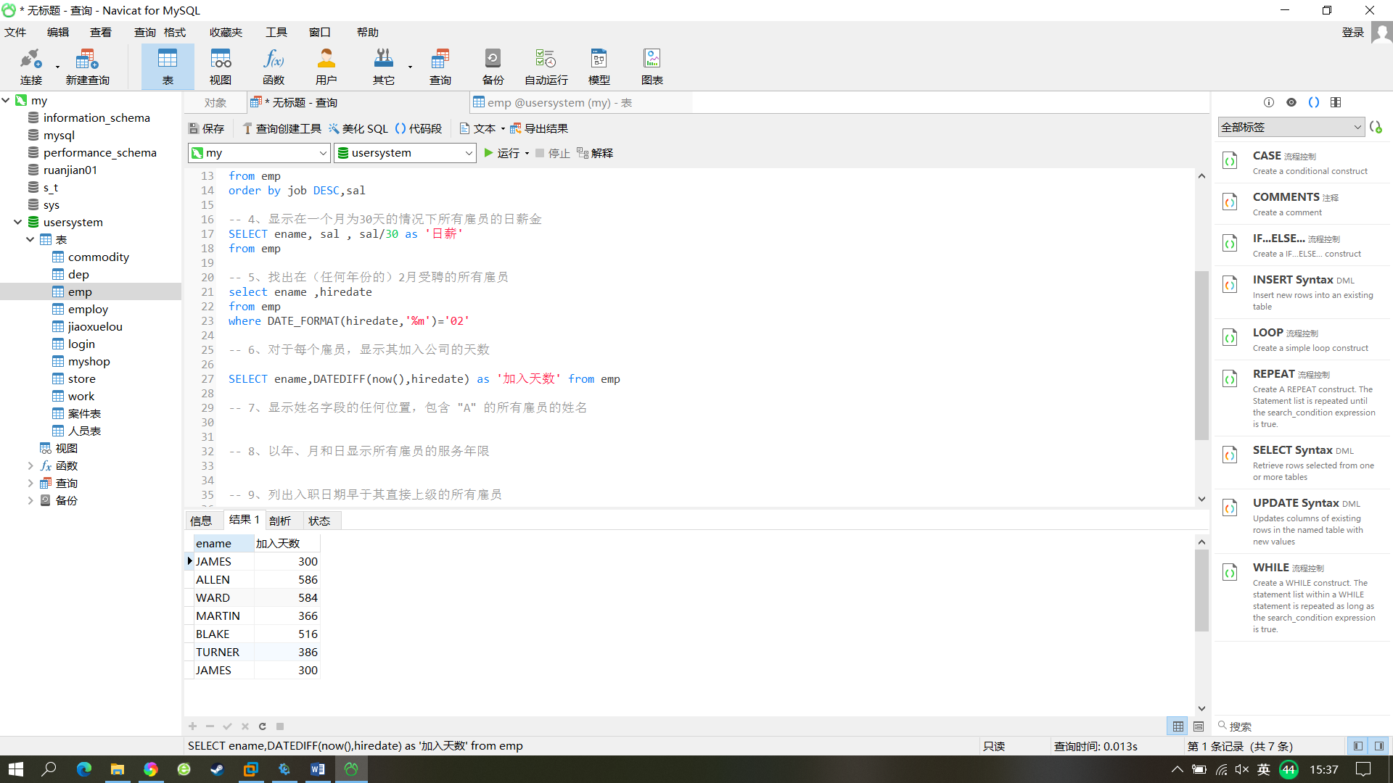

7、显示姓名字段的任何位置，包含 "A" 的所有雇员的姓名

|  |
| --- |
| select ename from emp where ename like '%A%' |

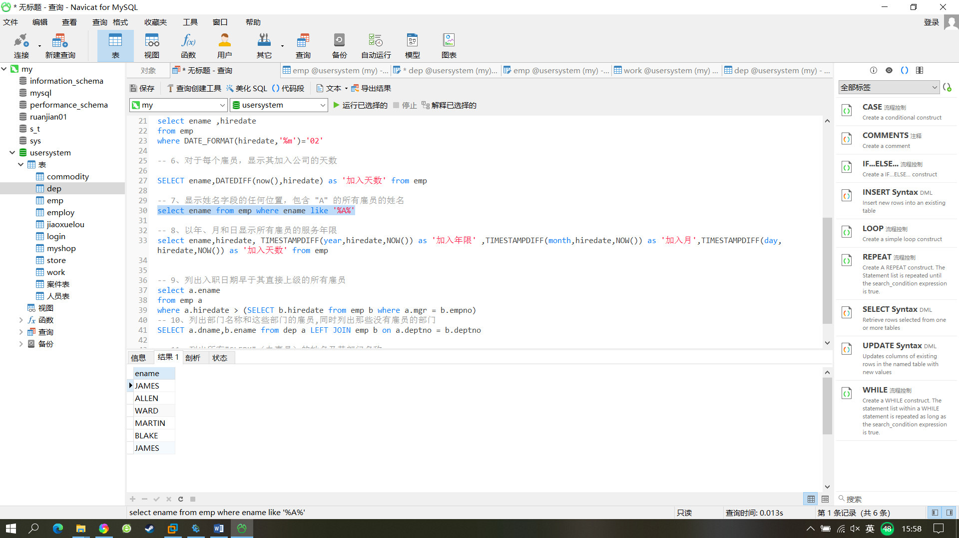

8、以年、月和日显示所有雇员的服务年限

|  |
| --- |
| select ename,hiredate, TIMESTAMPDIFF(year,hiredate,NOW()) as '加入年限' ,TIMESTAMPDIFF(month,hiredate,NOW()) as '加入月',TIMESTAMPDIFF(day,hiredate,NOW()) as '加入天数' from emp |

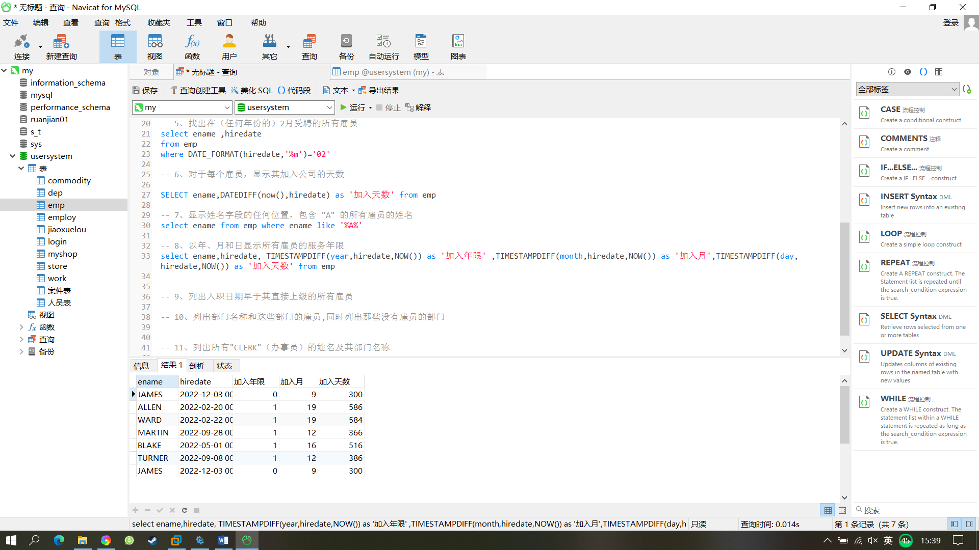

9、列出入职日期早于其直接上级的所有雇员

|  |
| --- |
| select a.ename  from emp a  where a.hiredate > (SELECT b.hiredate from emp b where a.mgr = b.empno) |
|  |

1. 列出部门名称和这些部门的雇员,同时列出那些没有雇员的部门

|  |
| --- |
| SELECT a.dname,b.ename from dep a LEFT JOIN emp b on a.deptno = b.deptno |

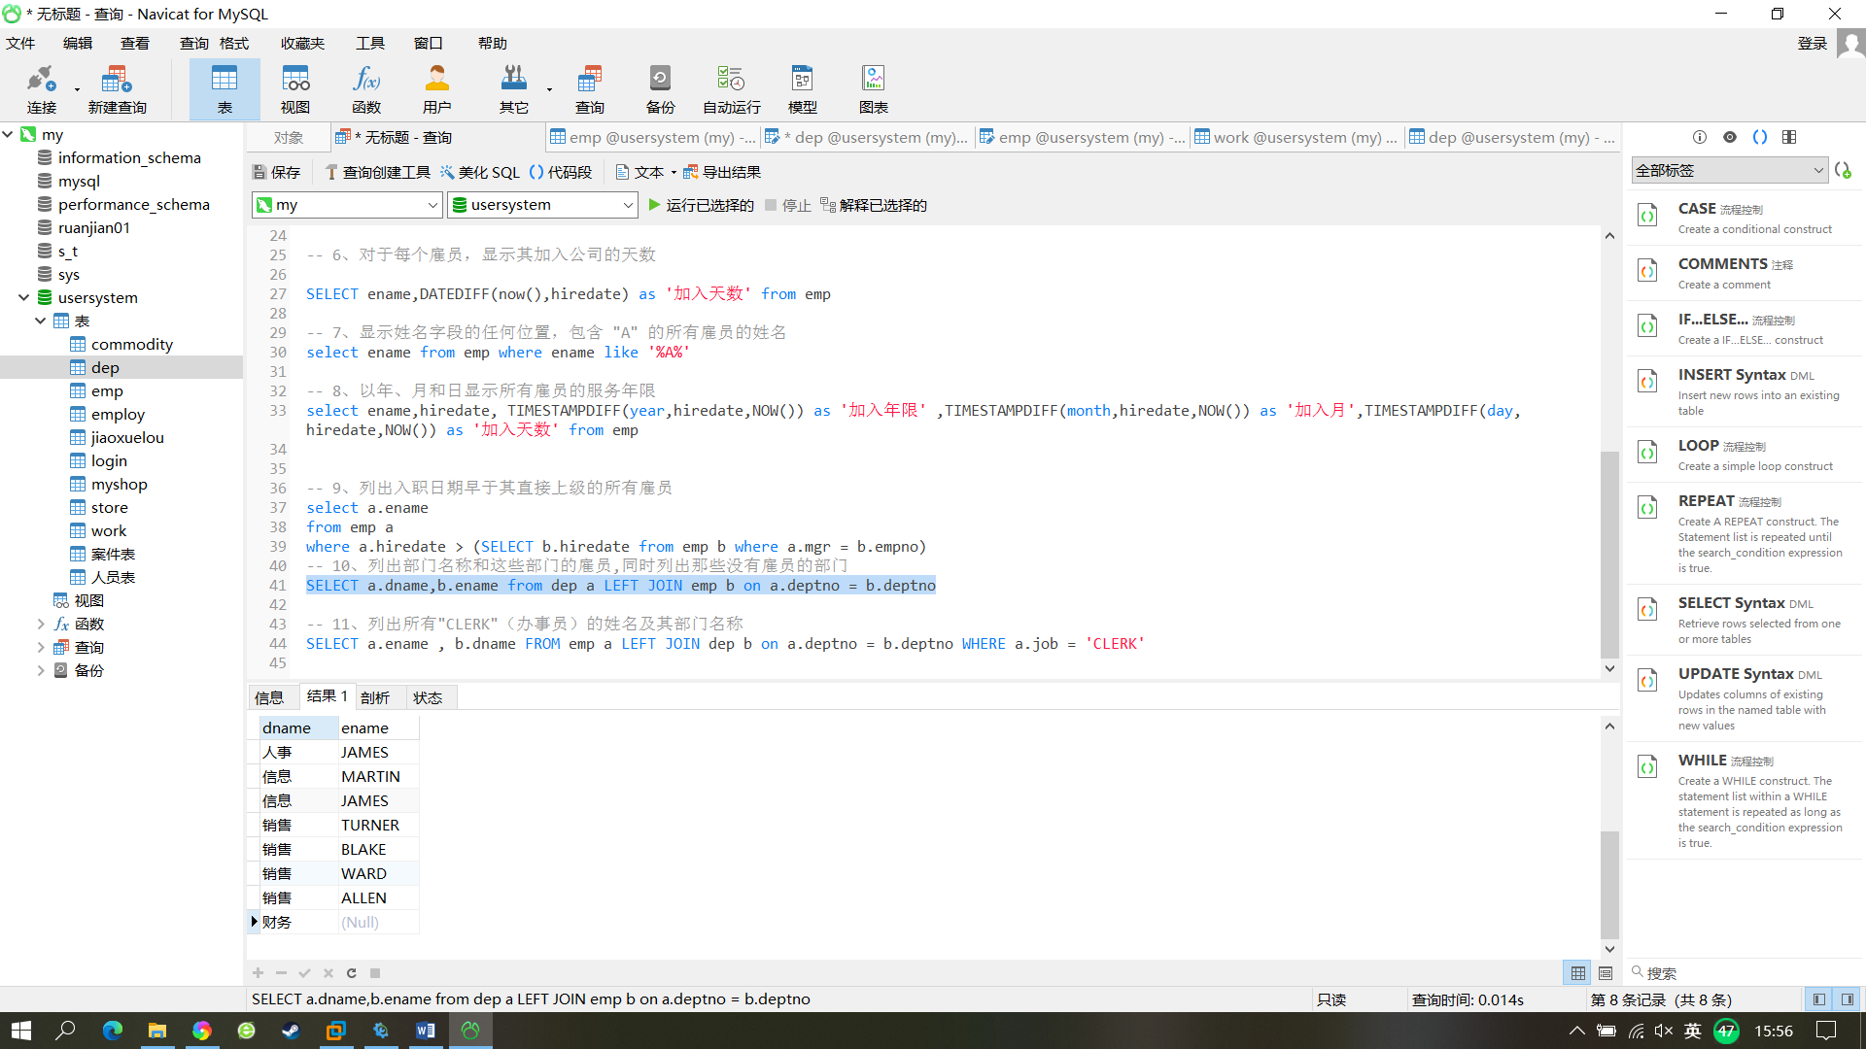

1. 列出所有"CLERK"（办事员）的姓名及其部门名称

|  |
| --- |
| SELECT a.ename , b.dname FROM emp a LEFT JOIN dep b on a.deptno = b.deptno WHERE a.job = 'CLERK' |

